horizontal line

EE208:CONTROL ENGINEERING LAB 04

# Controller design on MATLAB platform using discrete root loci

## 

## Course Instructor : Dr. Sanjay Roy

## Date : 4th February 2022



## Group Number - 14

## 

## Raj Kumar Deb 2020eeb1025

## Tushar Sharma 2020eeb1325

## Tiya Jain 2020eeb1213

# TABLE OF CONTENTS

**TABLE OF CONTENTS** **2**

**1. OBJECTIVE** **3**

**2. GIVEN** **3**

2.1 Given Block Diagram 3

2.2 Given Information of OLTF 3

**3. THEORY** **4**

3.1 Closed Loop Transfer Function Block Diagram 4

3.2 Closed Loop Transfer Function 4

**4. OBSERVATIONS & THEIR ANALYSIS** **5**

4.1 Approach to designing a desired digital system 5

4.2 Analysis for various cases 5

4.2.1 Observing Root Loci analysis of GIVEN ZEROS 6

4.2.2 CHANGING THE OL ZEROES 7

COMMENTS ON STABILITY 8

OBSERVING THE FREQUENCIES OF SUSTAINED OSCILLATION 8

SENSITIVITY ANALYSIS OF CLTF WRT PARAMETERS 11

**5. CONCLUSION** **12**

# 

# 

# 

# 1. OBJECTIVE

* This project requires us to design a cascade feedback controller for a given digital transfer function, according to desired specifications.
* A sensitivity analysis for variation of key parameters is further required.

# 2. GIVEN

### 2.1 Given Block Diagram

###### 

***Figure 2.1 Block diagram for the OLTF of the given system***

### 2.2 Given Information of OLTF

|  |
| --- |

# 

# 3. THEORY

### 3.1 Closed Loop Transfer Function Block Diagram

### 

***Figure 3.1.1 Block diagram for the CLTF***

### 3.2 Closed Loop Transfer Function

The CLTF is written using the formula :

| = |
| --- |

# 

# 4. OBSERVATIONS & THEIR ANALYSIS

### 4.1 Approach to designing a desired digital system

For the system to be stable, the closed loop poles of the *discrete* domain or the roots of the characteristic equation must lie within the unit circle in the z-plane. Otherwise the system would be unstable or marginally stable.

If a simple pole in *discrete* domain lies at **|z| = 1**, the system becomes marginally stable (which is our case initially). Similarly if a pair of complex conjugate poles lie on the |z| = 1 circle, the system is marginally stable. A marginally stable system is one that, if given an impulse of finite magnitude as input, will not *"blow up"* and give an unbounded output, but neither will the output return to zero.

Thus, in order to determine stability, we must search for the intersection of the root locus with the unit circle.

### 4.2 Analysis for various cases

#### **4.2.1 Observing Root Loci analysis of GIVEN ZEROS**

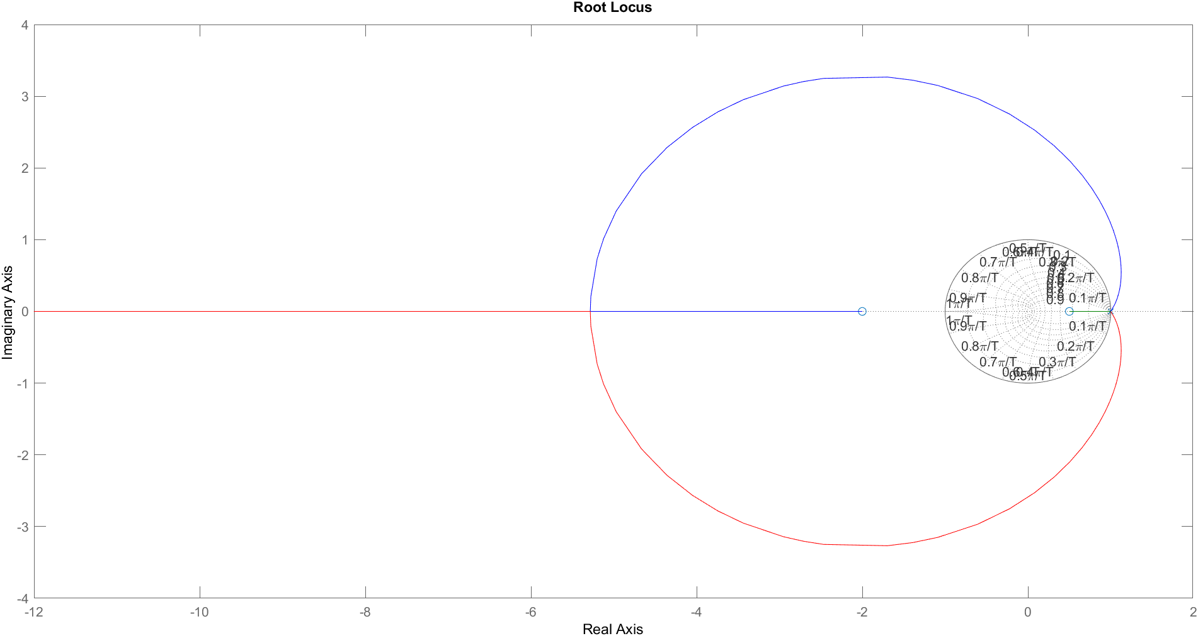

*Figure 4.2.1.1 Root Loci of the given OLTF*

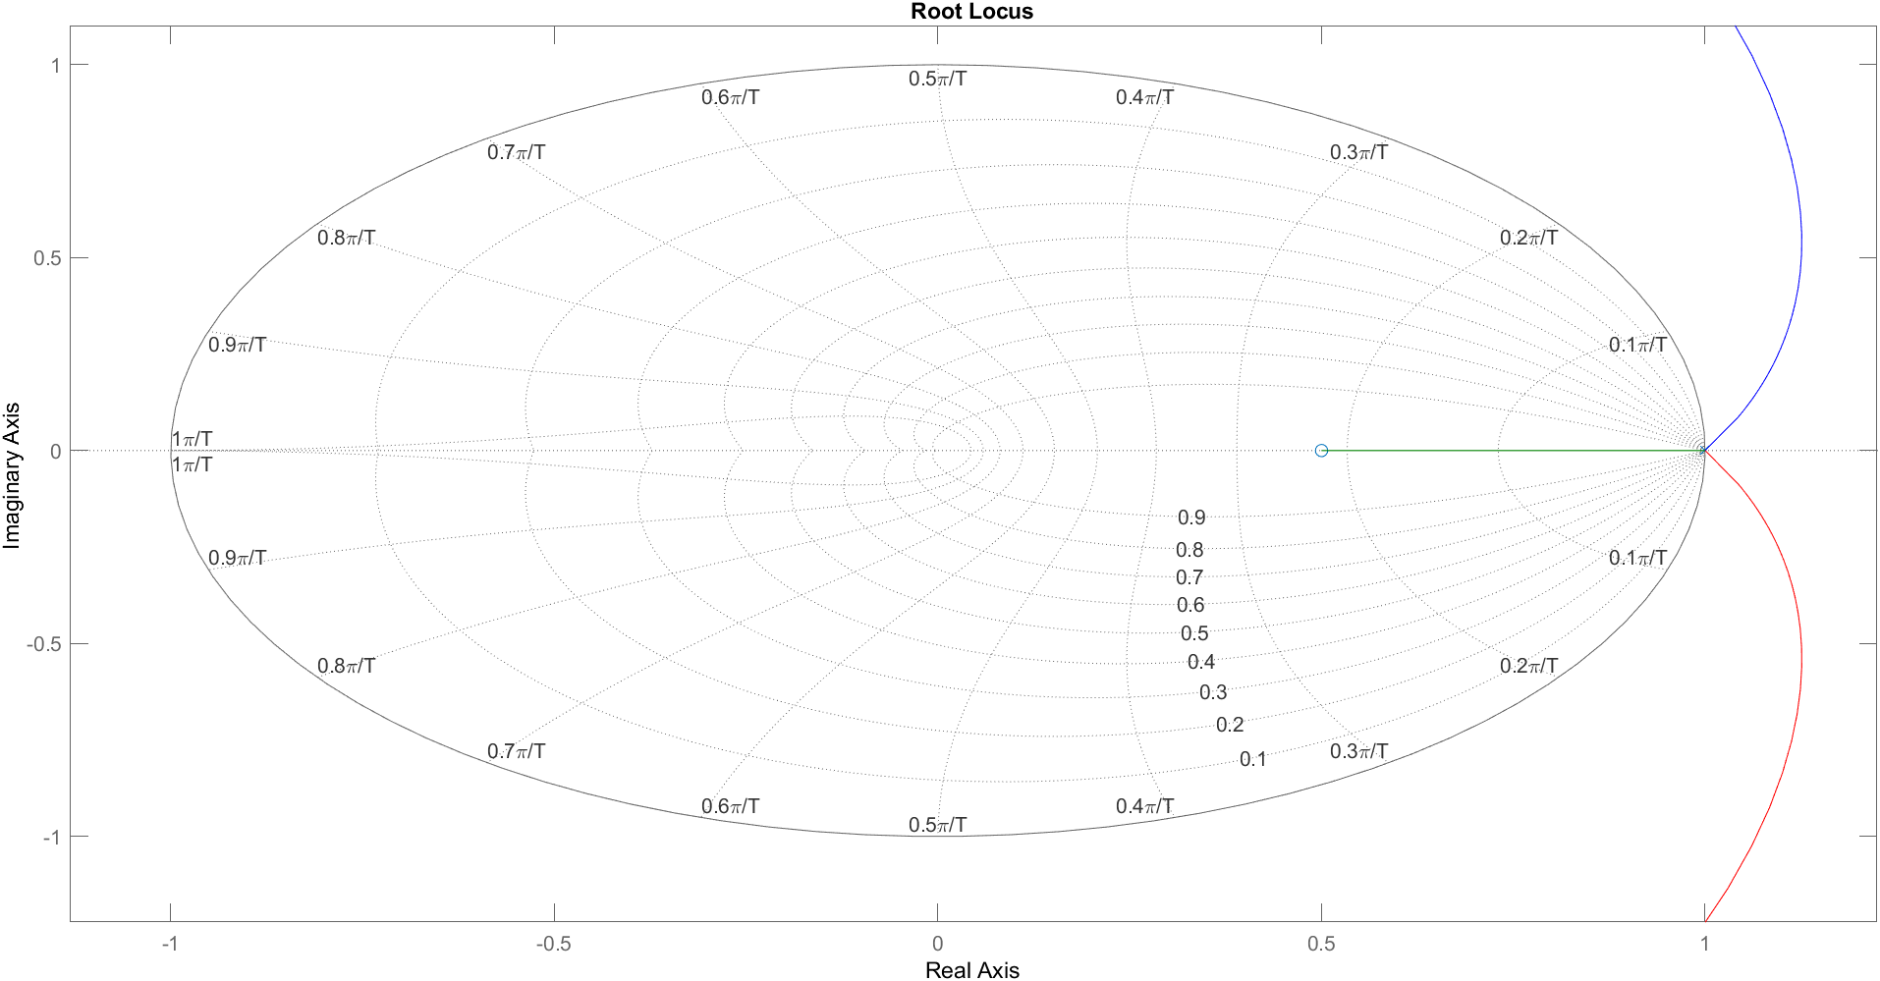

*Figure 4.2.1.2 Zoomed Root Loci of the given OLTF*

We obtained the rlocus plots using the given OLTF(*with given zeros at -2 and 0.5*).

**\*\* We observed in the zoomed image of the plot that there were no intersections possible of any conjugate pole pair with the unit circle. This means no matter how much we change the gain of the open loop, we won’t get any sustained oscillations. Hence the *given values of zeros cannot provide any sustained oscillation* with only change in Gain as it intersects the unit circle only for T = 0.**

* The system parameters were observed to be: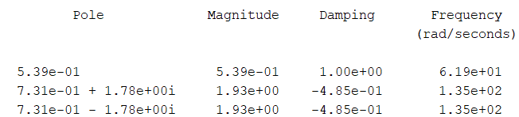
* We can notice that the discrete system has conjugate poles with *magnitude greater than 1* and a simple pole with *magnitude less than 1.* In the digital domain, this indicates that the system is unstable instead of marginally stable.
* We conclude that the **system is unstable** for the given values of zeros and as a consequence to the above observations we began to alter the open loop zeros.

#### **4.2.2 CHANGING THE OL ZEROES**

Using MATLAB we varied the value of zeroes and plotted the below graph:

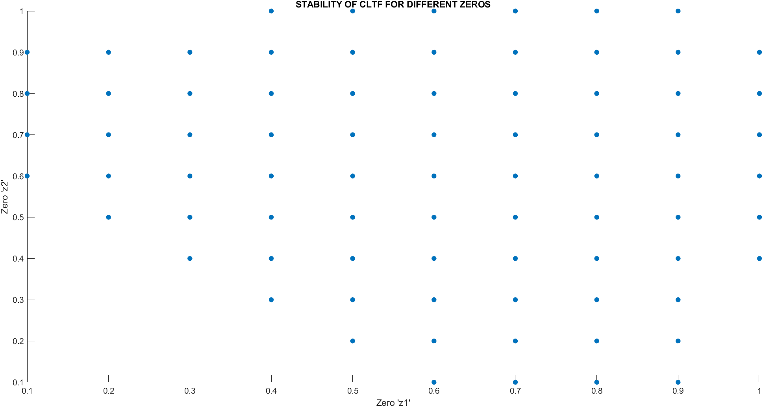

*Figure 4.2.2.1 Stability of CLTF for different zeroes*

**SCRIPT:** 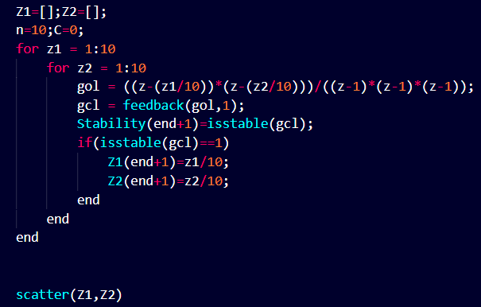

##### 

##### **COMMENTS ON STABILITY**

* We observe that the values of zeros which make the closed loop stable without changing the Gain ‘K’ are lying in the *range of* ***(0.4 to 0.8)***.
* This means if there is a transition between the unstable to stable system. Then maybe there may lie a value of Gain ‘K’ for which the system becomes ***marginally stable***.
* Same goes for other zeros when their magnitude is *less than 1*.

Now that we have come to the conclusion of stable points we shifted our focus to obtain and analyze the sustained oscillation frequencies.

##### **OBSERVING THE FREQUENCIES OF SUSTAINED OSCILLATION**

| *Figure 4.2.2.2 A: when zeros <1* | *Figure 4.2.2.2 B: when zeros >1* |
| --- | --- |

*Figure 4.2.2.2 Root Locus graph comparison*

* In the first graph with zeros *less than |1|*, we observe that there is an intersection between the zgrid and the root locus, whereas in the second graph with zeros *greater than |1|*, we observe that there is **no such possible** intersection between the zgrid and the root locus.
* So we find that we can obtain marginally stable systems with variation in Gain ‘K’ parameter in the root locus of the graphs of 1st type i.e. for zeros less than |1|. (The above attached plot is derived for zeros {*Z1 = 0.7, Z2 = 0.8*} and {*Z1 = 0.8, Z2 = 2*} ).
* Therefore we moved to find the Gain ‘K’ and the frequency for such marginally stable systems. A tabulated form of the observation is given below:

| | **Gain** | **0.4** | **0.5** | **0.6** | **0.7** | **0.8** | **0.9** | | --- | --- | --- | --- | --- | --- | --- | | **0.4** | 2.6755 | 1.8759 | 1.3155 | 0.89299 | 0.55118 | 0.2606 | | **0.5** | 1.8759 | 1.3336 | 0.95238 | 0.65904 | 0.41666 | 0.2016 | | **0.6** | 1.3155 | 0.95238 | 0.69445 | 0.49261 | 0.32043 | 0.16103 | | **0.7** | 0.89299 | 0.65904 | 0.49261 | 0.36015 | 0.24351 | 0.1287 | | **0.8** | 0.55118 | 0.41666 | 0.32043 | 0.24351 | 0.17361 | 0.09920 | | **0.9** | 0.2606 | 0.2016 | 0.16103 | 0.1287 | 0.09920 | 0.06501 |   *Table 1 : Variation of Gain with varying zeroes* | *Graph 1 : Variation of K wrt to different zeroes* |
| --- | --- | --- | --- | --- | --- | --- | --- | --- | --- | --- | --- | --- | --- | --- | --- | --- | --- | --- | --- | --- | --- | --- | --- | --- | --- | --- | --- | --- | --- | --- | --- | --- | --- | --- | --- | --- | --- | --- | --- | --- | --- | --- | --- | --- | --- | --- | --- | --- | --- | --- |

* To obtain the marginally stable condition, we vary the Gains of the following zeros and intersect them at a point where it intersects the zgrid (*here the damping ratio (*ζ*) is 0 i.e., the system is marginally stable*).
* We observe that the **sensitivity** of the Gains is *more w.r.t. lower values of zeros*, than the higher values. The change in gains is higher for lower values of zeros close to 0 than those close to 1. The value of Gain to obtain marginally stable maintains an inverse relationship with the zeros.

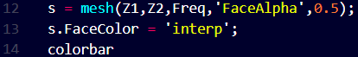

**SCRIPT:**

**\*\*\* For Sampling Time = T**

| | **Frequency** | **0.4** | **0.5** | **0.6** | **0.7** | **0.8** | **0.9** | | --- | --- | --- | --- | --- | --- | --- | | **0.4** | 1.7/T | 1.32/ T | 1.05/ T | 0.825/ T | 0.622/ T | 0.411/ T | | **0.5** | 1.32/ T | 1.05/ T | 0.841/ T | 0.667/ T | 0.505/ T | 0.335/ T | | **0.6** | 1.05/ T | 0.841/ T | 0.68/ T | 0.541/ T | 0.411/ T | 0.273/ T | | **0.7** | 0.825/ T | 0.667/ T | 0.541/ T | 0.432/ T | 0.329/ T | 0.219/ T | | **0.8** | 0.622/ T | 0.505/ T | 0.411/ T | 0.329/ T | 0.251/ T | 0.167/ T | | **0.9** | 0.411/ T | 0.335/ T | 0.273/ T | 0.219/ T | 0.167/ T | 0.111/ T |   *Table 2 : Trends observed in Natural Frequency w.r.t. variation in zeros* | *Graph 2: Variation in Natural Frequency w.r.t. variation in zeros* |
| --- | --- | --- | --- | --- | --- | --- | --- | --- | --- | --- | --- | --- | --- | --- | --- | --- | --- | --- | --- | --- | --- | --- | --- | --- | --- | --- | --- | --- | --- | --- | --- | --- | --- | --- | --- | --- | --- | --- | --- | --- | --- | --- | --- | --- | --- | --- | --- | --- | --- | --- |

* We observe the frequency obtained for the given zeros in terms of normalized frequency. We observe that the frequency is **more** **sensitive** for lower values of zeros (close to 0), and **less sensitive** for higher values of zero (close to 1). The rate of change is more for lower values of the zeros than as compared to the higher values of zeros.
* The value of *frequency maintains a direct relation* and the *sampling time maintains an inverse* relation with the zeros of the system.

Hence, we obtained the value of frequencies such that the system provides sustained oscillations. The location of zeros were modified in the range of (0 to 1). Among the various options to form the system with altered location of zeros, we select the one which is least prone to fluctuations, i.e. higher value of zeros.

***Zero 1 = 0.8, Zero 2 = 0.9 and Gain ‘K’ = 0.09920***

|  |
| --- |

The closed loop step response and root locus of the following transfer function will be as follows:

| **Root Loci Plot** | **Step Response** |
| --- | --- |
| **System Parameters** | **Step Response** |

From the root locus editor, we notice that we can obtain a point such that it is *guaranteed that there exists a Gain ‘K’* for which the system is marginally stable (ζ = 0). That value was found to be ***0.0992***. As observable from the step response, the response oscillates back and forth and neither settles to zero nor jumps towards infinity. The following frequency of *167* was calculated for a *sampling time of 0.001*.

**SCRIPT:**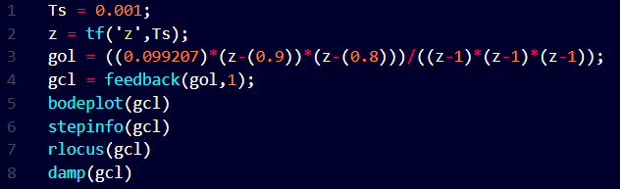

##### **SENSITIVITY ANALYSIS OF CLTF WRT PARAMETERS**

In order to showcase the concept of sensitivity we find the differential form of sensitivity wrt to our three parameters (the two zeros A and B, in our case and gain K)

**Note:** While analysing the sensitivity, we assumed that the system operates across a wide frequency range (bandwidth), thus we looked at the greatest sensitivity throughout a range of frequencies.

We analysed max|| , max|| and max|| w.r.t. A,B and K and observe that the sensitivity remains almost negligible throughout the lesser magnitude of zeros (~0.4 - 0.7) but for the higher magnitude (~0.7 - 0.9), the sensitivity is extremely high.

**We conclude from the analysis that as we pick higher values of zeros the open loop transfer function becomes more sensitive.**

# 5. CONCLUSION

* Root Loci Analysis was done for the given zeros and the system was found to be unstable even on varying K.
* For numerous locations of open loop zeros the undamped sustained frequency dynamics were successfully found and plotted.
* The values of ***Gain K*** are found for various combinations of zeros (from z1=z2=0.4 to z1=z2=0.9) for which the system remains undamped. The corresponding natural frequencies are also mentioned above in the tables.
* The sensitivities of the CL system w.r.t. A, B & K were calculated and analysed.
* After concluding that for values of zeros closer to 1, the various parameter sensitivity reduces, we consider our final CLTF with zeroes of OLTF as z1=0.8, z2=0.9. With a cascade gain of 0.0992 (for sustained oscillation). Hence our final CLTF is

,

where